sirine dhib groupe c td:9 tp:17

# COMPTE RENDU C#

ex1:

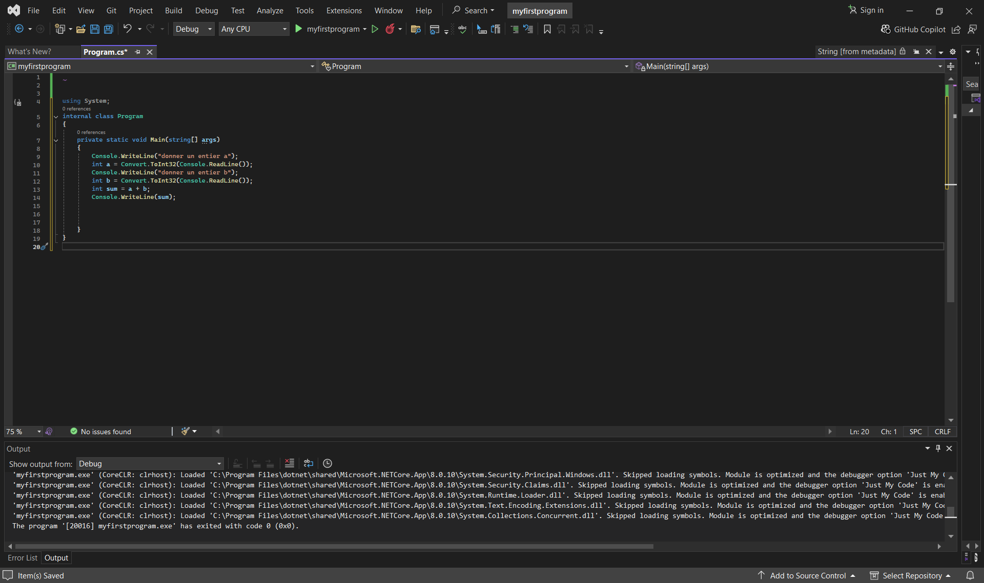

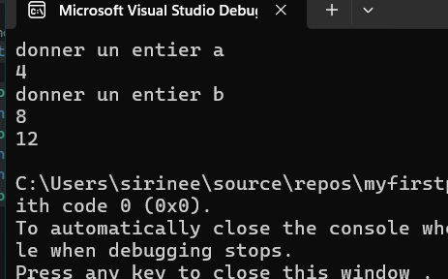 output:

ex2:

output:

ex3:

output:

